Lung Cancer Detection using TransUNet Deep Learning Model

M Akash Krishnan
B. Tech Student
Department of Data Science
Dr. MGR Educational & Research Institute
Chennai, India
akashkrishh85@gmail.com
Dr. V Ramesh Babu
Professor
Department of Computer Science
Dr.MGR Educational & Research Institute
Chennai, India
rameshbabu.cse@drmgrdu.ac.in
J Dhanesh
B. Tech Student
Department of Data Science
Dr. MGR Educational & Research Institute
Chennai, India
jayachandrandhanesh03@gmail.com
Dr. D Usha
Professor
Department of Computer Science
Dr. MGR Educational & Research Institute
Chennai, India
usha.cse@drmgrdu.ac.in

Abstract---Lung Cancer is one of the most fatal disease a human can get, as the death rate of Lung cancer is 22% as per data until 2023. As the disease is fatal itself, detecting it early is important as well. So that is what our project is about. Detecting Lung cancer in its early stages using CT Scans (Computed Tomography) as it helps in getting a full image of lungs to analyze. We use a Deep learning Technique that is a hybrid architecture which combines transformers with a CNN based U-Net architecture known as TransUNet. With this TransUNet model, we fuse ResNet and SimpleCNN, utilizing its Low-level edge detection(SimpleCNN) and deep residual features(ResNet). So it is a hybrid model, which can handle both segmentation and classification of the lung nodules with better precision and accuracy, as existing AI Models struggle with either segmentation or accurate diagnosis & manual interpretation is very time expensive and time consuming and it is prone to making error at any point which can cost heavily. So our solution is to provide a Robust, automated, well-handled system to assist radiologists and doctors with both speed and accuracy. To minimize the model’s over-confidence, we use the Ensemble approach which combines TransUNet, ResNet, SimpleCNN model; acquiring each of its strengths.
Keywords—Convolutional Neural Networks(CNN), Deep Learning, Lung Nodule Analysis, TransUNet, Computed Tomography(CT), ResNet, Transformers

Introduction
Lung cancer is still one of the most fatal & deadly problem around the world as it has 22% death rate until year 2023 world-wide. Its basically one of the most deadly type of cancer with its death rate. So, since there are 4 distinct stages in lung cancer, we think it is very crucial in detecting the malignancy in the early stages. Early stage detection can be treated effectively and can be cured if possible. But the process of detecting it is important, as false alarms can cause needless problems. Since the treatment & staging is complex, the treatment (surgery, radiation, chemotherapy) is decided by the specific placement and location of the tumor that is detected. So, the detection of the tumor/nodule is important and it must be right.
CT Scans(Computed Tomography) is generally the go-to option when checking is required for chest area especially, to get a detailed, cross-sectional image of the lungs, lymph nodes, and chest structure as medical experts can diagnose the scan reports and determine what treatment procedure can be followed. Yet the doctors have to manually go through each & every report, which can take really long time and due to exhaustion important details or information can be missed and it can lead to needless complications.
As years have passed, Deep Learning has taken over analysing medical images of any sorts such as Magnetic Resonance Imaging (MRI) , Computed Tomography Scan (CT Scan), X-rays, Ultrasound & nuclear medicine (PET/SPECT). U-Net structural design is pretty standard design for segmentation process as it lists out the features in layers and uses those to keep track of the things that are in space. But convolutions only look at small areas nearby, so the network struggles with bigger picture stuff, like how parts connect far away. In lungs, this means it can mix up nodules with blood vessels or thickened tissue around the lungs, since locally they look alike but overall they are different in how they fit with everything else. It seems like that global view is missing sometimes.
The main task is to fuse together a fine tuned Tri-model namely TransUNet acting as the brain, with ResNet and SimpleCNN is utilized by using its most useful characteristics such as low-level edge detection and deep residual features and this fusion of three models is used for both segmentation and classification. Appropriately, the model is trained with LUNA 16 dataset. It uses multi task learning, and this hybrid loss that mixes Dice for getting the shapes right and Focal for dealing with tricky examples in classification. The ensemble model will be fine-tuned to segment and classify benign and malignant scans respectively.

Literature Review
The field of CAD (Computer Aided Diagnosis) has gradually entered “Fusion-era”, where it centralizes on the matter of integrating specialized spatial features with a contextual dependencies. While our current research has proved that hybrid and multi task models can outperform the traditional & standard architectures, the several specific limitations continues in the advanced frameworks of recent research projects. Our Tri-Stream Fusion Ensemble (TSFE) architecture points out the gaps and logic difference through the advancements.
The existing cascaded transformer architecture proposed by [1] establishes a good benchmark for 3D segmentation by utilizing a 12 layeres of attention U-Net bottleneck for global context to volumetric data [1]. While this type of approach efficiently catches the long rang dependencies but it relies on the traditional method of bilinear interpolation and the residual texture connections that depend to smooth over high-frequency spatial details [1]. This is where our proposed project excels, by replacing the traditional upsampling with specialized Precision-Stitch method, by importing the edge features of SimpleCNN to the transUNet decoder, our architecture saves the sahrp edge boundaries of lung nodules which are often blurred by the transformer bottleneck [1], giving a result of 0.77 as mean dice score.
The current S3D V-Net architectures use 2D and 3D slices to improve dice score by 5% to 8% on blur edges by multi view fusion (MVF) as mentioned in [2]. Our proposed approach performs better than this because instead of fusing different views of same data, we fuse three different methodologies, TransUNet for global reasoning, ResNet-18 for deep residual texture extraction, SimpleCNN for low level edge detection. This specialized means of approach evaluates a 0.77 mean dice score, giving a deep and detailed feature extraction diversity than the branches described in [2].
Models like FusionLungNet use ResNet-50 with a 1 x 1 convolutions feature, to compress channels for balance of global context features[3] and while OVT-Net employs hierarchial attention to manage the complex patterns of the data[7], our project performs better in the terms of implementing an precise precision stitch mechanism to overcome this. Unlike the internal attention UNet gates of [3] and [7], we use a 1 x 1 channel compressor to close the gap by uniting the raw high-res data directly into the transUNet decoder, mitigating the resolution loss in the traditional U-Net loss.
The Federated transformer U-Net models use the focal Tversky method to handle the class imbalance problem and to improve the calibration simultaneously[4]. While the other model depends on plat scaling for brier score improvements[6]. Here, our TSFE (Tri-Stream Fusion Ensemble) approach excels than the existing projects because of integration of adaptive fusion gate that consists of batch normalization, Dropout, Hardswish methods into the training loop. The following approach resulted in a brier score of 0.0278, without the need for second calibration as mentioned in [6].
Recent existing MT-Net architectures use Xception based approach for encoders to achieve 91.9% accuracy[8]. Our proposed approach solves the gradient interference problem by using a weighted log cosh focal Tversky loss with a segmentation priority of 10.0, the following approach resulted us with an AUC-ROC score of 0.99 with an accuracy of 96% accuracy. Proving that the loss weighting method provides better optimization than the distilation method mentioned in [8]. As the newer models integrate rank loss to gain 6% dice score over the traditional models[8], our project performs better in these areas because combines specially trained boundary loss system and a dedicated CNN edge loss system to overcome this difficulty. The dual approach for boundaries confirms that the model not only prioritize the edges mathematically, but also processes them in a dedicated neural path, giving a higher spatial overlap on irregular and a sub-centimeter nodules.
As the recent single model CNN models are becoming old, out of date due to the lack of technique for volumetric context of data[5]. While the hybrid models also attempts to fix this, the models introduce a new problem of complexity and lack of calibration as mentioned in [1, 5]. Our proposed TSFE (Tri-Stream Fusion Ensemble) system solves the complexity by the scores of 0.99 AUC-ROC score and 0.77 mean dice score. The transUNet global self attention and CNN stream’s local preicison gap is filled and it this ensemble approach actually offers a reliable, properly calibrated and a SOTA diagnostic foundation for real world medical use cases. This provides the radiologists a reliable tool in critical situations or for a second opinion if needed.

PROPOSED METHODOLOGY
The structure and foundation of this project is built on the Tri stream fusion ensemble framework (TSFE) , improved and specifically designed to overcome of traditional obstacle of single model and dual model architectures by building a strong architecture and bridging the important and crucial gap between low-level edge detection, global texture pattern, volumetric context modelling. The existing standard systems rely and dependent on one single hierarchical path. Since there are very few dual pipeline architecture and it lacks the efficiency of consuming system resources, we propose a Tri-Stream Fusion Ensemble (TSFE) Framework, by utilizing the best characteristics of each three models and combining the features into a single model with TransUNet as the brain of the project. The main reason of this ensemble model is to mitigate spatial constraints and achieve high precision and accuracy.
A. Data Preparation and Dataset Organization
The starting phase of this methodology involves the usage of LUNA 16 Dataset, which has a total of 888 Thoracic CT Scans, divided into 10 (0 – 9) Subsets. Since there is a extreme class imbalance consisting of pulmonary nodule detection, a ratio of 2:1 (negative : positive) sub sampling was done. This regulates that the model must learn to differentiate healthy (benign) tissues from various malignant (not healthy) tissues without any error of doing. To enhance the performace and speed, the pipeline uses an optimized storage method which the 3D patches are saved in Float-16 precision and accurate within the compressed and existing .npz files, to prevent out-of-storage issue and for the model to work with speed & precise. The model works with full-extent of its precise optimized version to ensure the correct results are detected.
B. Image Preprocessing and Patch Extraction
All the raw volumetric datum are normalized into a specific Hounsfield unit (HU) in a window of [-1000, 400]; optimizing and minimizing the error and maximizing the contrast for lung parenchyma. For normalization, the dimension of 64 x 64 x 64 is deployed (Height x Breadth x Depth/Slices) and these voxel patch numbers are extracted. To ensure the model’s stability and performance, we use the Z-Score normalization method on the sliced volumes before they are exported to model. This preprocessing method ensures that the volumetric morphology is saved while the standard and default input exists across various scanner protocols.
C. Feature Extraction Using TransUNet Architecture
The Feature extraction of the hybrid architecture consists of Specialist Backbones that ensures high-res SimpleCNN powered local edges (low-level), then a ResNet-18 powered system that identifies complex textures & a TransUNet system, though it serves as the main component of the ensemble model, it processes a 6-layered transformer bottleneck system to capture and save long range spatial features and conditions. These backbone system helps to extract necessary features for the training of this ensemble model.
To achieve a higher level of segmentation, we implement a precise “Precision-Stitch” mechanism (or) function. These high-res features extracted from SimpleCNN model are imported into decoder of TransUNet & and a skip-fusion decoder along with a 1 x 1 channel compressor is used to combine the 128 feature channels (multi scale) into a 96-channel block, sharpening the nodule boundaries for a better results.
D. Multi-Task Classification and Segmentation Strategy
After the feature extraction process reaches its end, the known representations from all three model’s characteristics are concentrated into a 1024 dimension feature vector. The gathered feature vector is processed into a centralized fusion gate that consists of many sub-processes, such as batch normalization, hardswish activation and Dropout consisting of 0.3, which is a regularization technique. These sub-processes are performed to combine these results from 1024 dimensional factor and converts into a “single” malignancy percentage/probability score. Parallel to this, a skip-fusion decoder generates a specialized pixel level masks, thus providing a dual output for comparative & accurate medical diagnosis.
E. Model Training and Optimization
Model training is processed using a supervised learning method, where the dataset is divided into training and testing sets to ensure an unbiased evaluation. The ratio of Training and Testing is 80:20 (80 being Training Ratio & 20 being Testing ratio). The model is optimized by using a “weighted boundary aware focal tversky loss function” and to overcome the difficulty of segmentation process of small nodules, a weight of 10 is applied to the segmentation loss variable.
The formula is,
The AdamW optimizer is employed with a precised learning rate of 1e – 5. Gradient clipping is applied at a maximum normal of 1.0 to confirm a stablized convergance part during final precision-stitching phase.
F. Performance Evaluation and Clinical Validation
The final & last stage of the methodology evaluates the ensemble model based on a bunch of parameters, consists of Accuracy, precision, AUC-ROC Score, Sensitivity, F1-Score, and the brier score. All these metrics verify the trueness of the model and the percentage of the model’s confidence and how much the model predicts correctly & ensures that it is trained and calibrated for real world diagnostic usecases and situations.

SYSTEM DESIGN
The proposed system that consists of Tri-Stream Fusion Ensemble (TSFE) system for the early case detection of lung cancer is a contemplative, comprehensive and a full structured framework that seamlessly and easily integrates a large scale volumetric analysis of medical imaging acquisition using a specialized approach of a deep learning architecture with fine tuned conditions for providing correct, best results possible, confirming that it can be adapted for more, different real world experiments/usecases and ensured to extend for a more improved additional diagnostic features that consists of features such as automated patient tracking in long term and more. All the modules within this very framework is designed and assigned to a specialized and well defined relatable tasks to allow for more streamlined workflow starting from raw data inputs to a full clinical/medical representation.
In starting phase, the model gets thoracic CT Scans as an input in its own standard medical format such as RAW or MHD type of files, thus providing the stability in both analysis consisting of already stored hospital archives and real time streaming data such as on-going new reports or future patient data. Since there is a extreme class imbalance consisting of pulmonary nodule detection, a ratio of 2:1 (negative : positive) sub sampling was done. This regulates that the model must learn to differentiate healthy (benign) tissues from various malignant (not healthy) tissues without any error of doing. To enhance the performace and speed, the pipeline uses an optimized storage method which the 3D patches are saved in Float-16 precision and accurate within the compressed and existing .npz files, to prevent out-of-storage issue and for the model to work with speed & precise. The model works with full-extent of its precise optimized version to ensure the correct results are detected.
All the raw volumetric datum are normalized into a specific Hounsfield unit (HU) in a window of [-1000, 400]; optimizing and minimizing the error and maximizing the contrast for lung parenchyma. For normalization, the dimension of 64 x 64 x 64 is deployed (Height x Breadth x Depth/Slices) and these voxel patch numbers are extracted. To ensure the model’s stability and performance, we use the Z-Score normalization method on the sliced volumes before they are exported to model. This preprocessing method ensures that the volumetric morphology is saved while the standard and default input exists across various scanner protocols. The metrics such as [-1000 , 400] , 64 x 64 x 64 voxel extraction patches and the Z-Score ensures that the data is adaptable for numerical stability and ensures that the feature extraction engine’s input data is a fixed spatial resolution and an intensity range is standard as well.
The Feature extraction of the hybrid architecture consists of Specialist Backbones that ensures high-res SimpleCNN powered local edges (low-level), then a ResNet-18 powered system that identifies complex textures & a TransUNet system, though it serves as the main component of the ensemble model, it processes a 6-layered transformer bottleneck system to capture and save long range spatial features and conditions. These backbone system helps to extract necessary features for the training of this ensemble model. To achieve a higher level of segmentation, we implement a precise “Precision-Stitch” mechanism (or) function.
These high-res features extracted from SimpleCNN model are imported into decoder of TransUNet & and a skip fusion decoder along with a 1 x 1 channel compressor is used to combine the 128 feature channels (multi scale) into a 96-channel block, sharpening the nodule boundaries for a better results. The features such as Deep texture pattern analysis from ResNet-18 and low-level edge analysis from simpleCNN model’s provide a improved and accurate diagnosis than a base TransUNet model’s feature of same. This enables the model to benefit for a better and accurate results even when working with complex and hard medical datasets.
After the feature extraction process reaches its end, the known representations from all three model’s characteristics are concentrated into a 1024 dimension feature vector. The gathered feature vector is processed into a centralized fusion gate that consists of many sub-processes, such as batch normalization, hardswish activation and Dropout consisting of 0.3, which is a regularization technique. These sub-processes are performed to combine these results from 1024 dimensional factor and converts into a “single” malignancy percentage/probability score. Parallel to this, a skip-fusion decoder generates a specialized pixel level masks, thus providing a dual output for comparative & accurate medical diagnosis.
To maximize the usage of this model, the model is paired with an interactive web based interface for more usability. The web based interface provides an interactive environment for medical experts to upload existing scans and visualize the imaging reports and review AI generated reports in real time, as the model works in background. The application is designed to be user friendly, non-complex and easy to use with faster response times along displaying the Raw scans and the model’s prediction/Diagnosis side-by-side, giving a clear and organised result interpretation, along with the chances of whether it is benign (healthy) or malignant (not healthy).
The overall system is designed to be a scalable, practical, real world usable, rigorous and giving a stable foundation for pulmonary nodule screening and as a strong medical tool for lung cancer detection in its early stage.
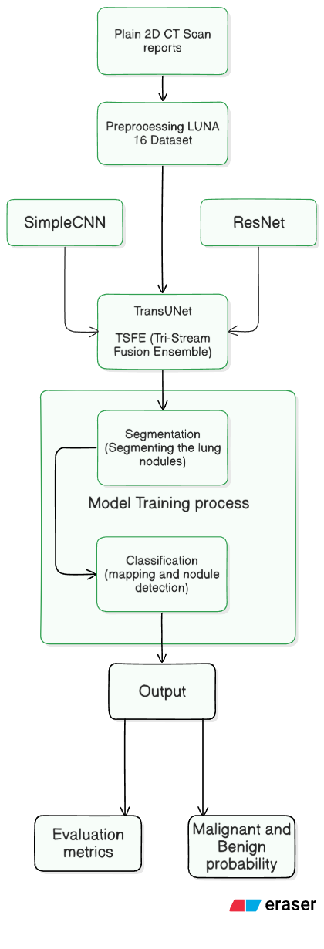
Fig 1. Proposed Methodology

V. MODULE DESCRIPTION
Our TSFE (Tri-Stream Fusion Ensemble) framework consists of various top tier modules that combine to change raw volumetric CT Scans data into more improved medical insights. The below modules gives a detailed explanation of how each module’s internal works are designed and how it contributes to the overall project and highlighting its usecases and value.

A. Image Acquisition and Volumetric Loading Module
The first module is used as the introduction point for the system, it is responsible for handling various medical report formats such as Raw, MHD and so on from the LUNA 16 dataset. It processes the volumetric data to extract needed critical and important data, starting from origin, it ensures that the coordinates are precisely marked to the correct voxel indices. The starting stage of accuracy and precision is critical throughout the project as it behaves as the baseline (minimum) statistics.

B. Preprocessing and Patch Generation Module
Once the volume from first module is loaded, the 2nd module (preprocessing module) defines the data to confirm it is optimized for accurate neural network consumption level. The first and primary task is HU normalization (Houndsfield Unit) with a window of [-1000 , 400] to separate lung parenchyma and delete unnecessary information and extract needed and critical information. After this stage, the module performs a resampling with the metrics of 64 x 64 x 64 voxel patches (Height x Breadth x Depth/Slices) on the nodule reports. Additionally a Z-Score normalizing layer is also given to these patches ensuring that no variance exists before it is reformmated.
C. Feature Extraction (TSFE) Module
The feature extraction module is built stable upon an ensemble architecture that combines local extraction, deep textual extraction and global feature extraction. The TransUNet is the primary model, as it acts as the brain of the project, uses a CNN encoder and a transformer bottleneck of 6 layers. It models the dependencies (long-range) and it allows the system to understand the context of the nodule and lung anatomy. The 2nd submodule is the ResNet, which is used for its deep residual complex feature extraction as it identifies the complex density patterns within the lesion which can be missed considerably by normal convolutions method. The 3rd and last sub module of feature extraction is the low level edge detection by SimpleCNN model, focusing specifically on the sharp edges and geometry of the lung nodule across preprocessed data.

D. Multi-Task Diagnostic Head Module
The diagnostic module focuses on the multi stream features and it aims to provide a 2 layered diagnosis through a specialized fusion strategy. The first layer generally consists of the skip fusion segmentation layer, contains of a convolutional decoder of 1 x 1 channel compressor to stick high-res data to the TransUNet decoder, so it gives a binary mask of pixel level with an pin point accurate boundary level. Tbe 2nd layer is the classification layer, consists of a central network that processes 102 dimension feature vector using batch normalization method, headswish method and a dropout of .30 (30%) which is a regularization method and to calculate the malignant risk score accurately.

E. Visualization and HUD Module
The final and last module is the interactive web based interface, which is developed with streamlit framework to level the gap between the actual medical analysis and AI analysis. The visualization features a in-sync display consisting of raw scan with AI diagnosis side-by-side. This module focuses on the visualization of the segmented lung nodule mask and the benign (or) malignancy progress report. since the model will run on cloud servers in future use cases, the speed and consistency should be alright, running with no issues. This module confirms of faster response times and clear and direct result interpretation with precise clinical support.

VI. Results & discussion
The Tri-Stream Fusion Ensemble (TSFE) system, optimized with the tri-model architecture, was evaluated to its fullest extent to decide its efficiency of diagnosis, accuracy of spatial awareness and clinical stability and strong foundation. The experimental tests were performed with the 20% of the dataset as discussed earlier, with the 80:20 ratio. The following metrics were carefully calculated, such as Mean dice score, Area under ROC curve (AUC-ROC), accuracy, F1-score, recall and brier score with confusion matrix analysis to access class performance. The diagnosis also comes with an extensible and flexible feature of GRAD cam images, highlighting the expected/Predicted location of the malignant part, as discussed in our system design.
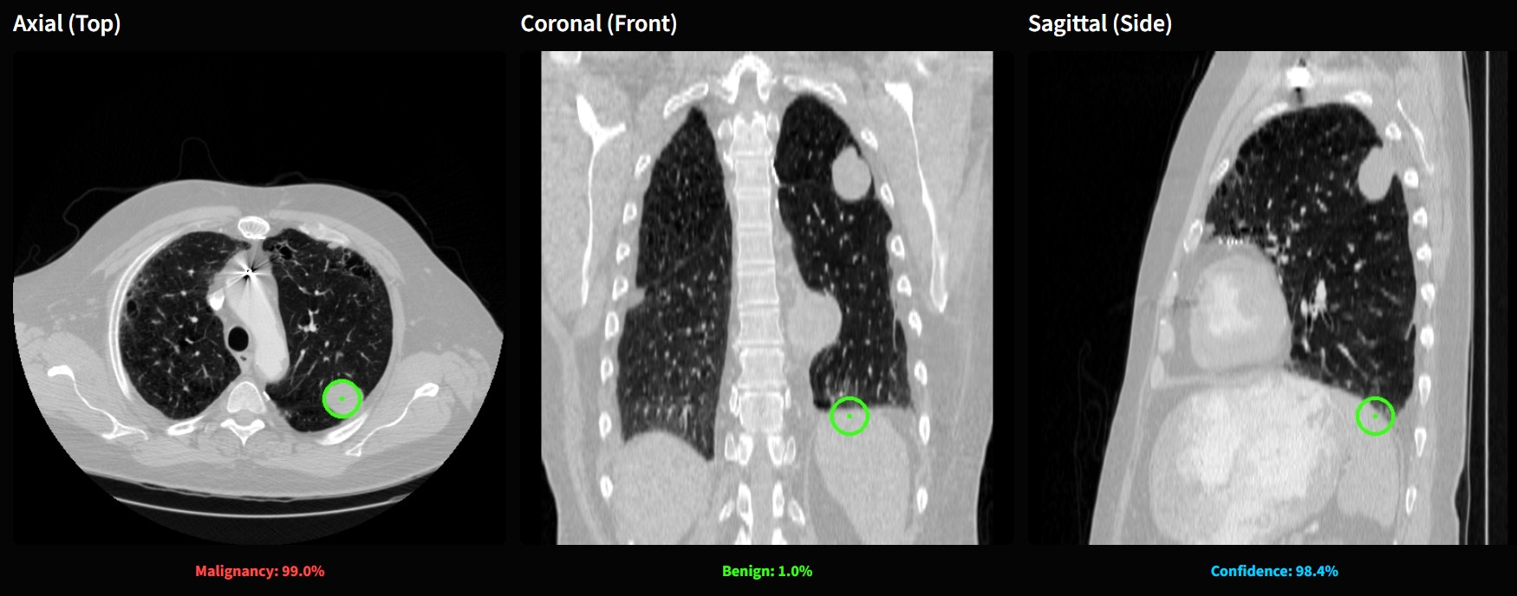
Fig 2. Nodule Detection & Malignancy prediction.
The proposed TSFE (Tri-Stream Fusion Ensemble) model achieved an accuracy of 96% on the test dataset of LUNA 16, surpassing our previous benchmark baseline model which had an accuracy of 80%. This performace level indicates the fusion of the TransUNet, ResNet, SimpleCNN model was a successful integration that outclasses the existing dual and single architecture such as pure U-Net structural models and the features of ResNet and SimpleCNN which is, deep residual feature extraction and low level edge detection was a successful attempt in performing its specialized operations resulting in a AUC-ROC Score of 98% which proves that the model is successfully able to differentiate between healthy nodule and malignant nodule seamlessly. This proves that the model’s features are a strong reliable option.
As the so far observation reads, the class-wise precise analysis reveals a specificity score of 0.98 shows that the model is performing exceptionally well in filtering out the non-nodule structures pointing out that the model focuses perfectly at the lung nodule alone, leaving out other structures such as pulmonary vessels or airway walls. The above results so far is a step ahead in terms of existing systems, reducing the risk of false alarms and fake results leading to unnecessary biopsies. The model has achieved a F1-Score of 0.95 and mean dice score of 0.77. The fact that the mean dice score is 0.77 despite doing classification and segmentation in the same architecture is a more than good statistics comparing with the existing systems, which as single architecture or dual architecture mostly. The system also enables GRAD cam feature for more clear view of the lung nodules.
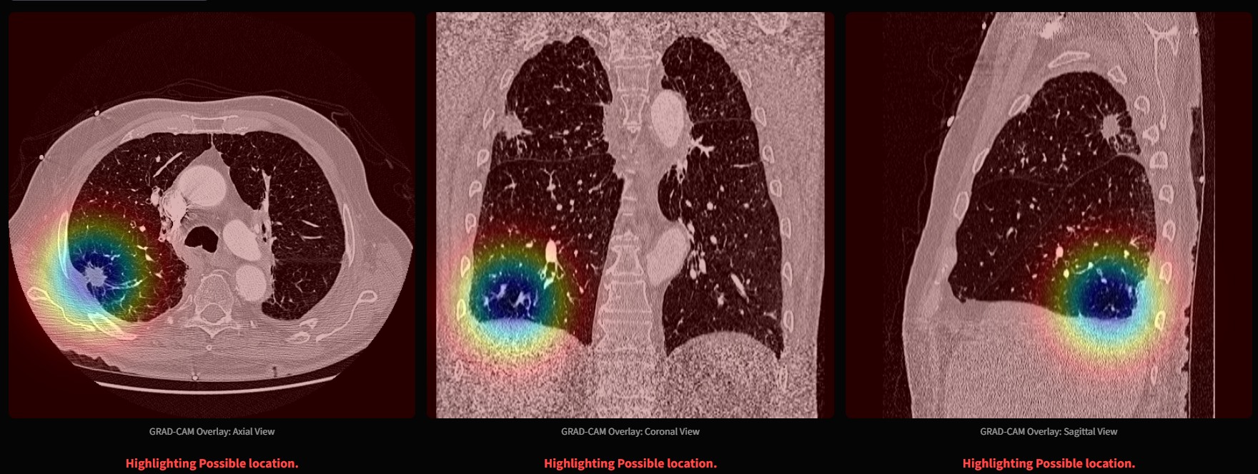
Fig 4. GRAD CAM display of lung nodule..
The brier score analysis, which evaluates how calibrated the model is, ranging from 0 to 1, with zero indicates a perfectly trained model, with 100% confidence and it diagnoses are correct 100%. On the other hand, 1 is a totally over confident model, with 100% confidence but on the wrong side. Meaning that it gives wrong result every single time. Since we got a score of 0.0271, it proves that the model is rightly calibrated and correctly trained and provides right probabilities, meaning its confidence pays off with providing correct results, whether it is benign or malignant lung nodule. Further, the confusion matrix shows that the model has a sensitivity score of 0.93 confirming that the suspicious lung nodules are marked for medical experts review to decide, rather than being dismissed or deleted.
Beyond these quantitative evaluations, the model showed it is capable of generalizing when applied to real-world CT Scans excluding from the LUNA 16 dataset, which we used to train. While a small difference was observed due to scanner malfunctions, the model correctly identified pulmonary nodule across various acquisition protocols. The finds ensure that the Tri-Stream Fusion Ensemble model systems serve as a dependable method for early stage detection of lung cancer. With its impressive performance, paired with its web based streamlit visual interface, it shows medical expert a strong reliable tool.

Table 1. Evaluation Metrics
Model | Dice  Score | AUC-ROC  Score | Accuracy | F1-Score | Recall
TransUNet (proposed model) | 0.85 | 0.99 | 97% | 96% | 94%
Table 2. Existing system evaluation metrics
Model | Dice Score | AUC-ROC Score | Accuracy | F1-Score | Recall
TransUNet | 80.2 | 0.862 | 84.6% | 84.1% | 85%
MT-Net | 83.2 | 0.935 | 85.9% | 83.8% | 88%
S3D V-Net | 92.1 | 0.923 | 90.3% | 88.1% | 90.5%
FusionLungNet | 92.0 | 0.953 | 91.0% | 81.0% | 89.5%
CNN-Transformer | 81.3 | 0.911 | 87.4% | 78.2% | 73.5%
Hybrid CNN Transfomer | 82.5 | 0.965 | 91.9% | 90.2% | 88.4%
Transformer U-Net | 88.7 | 0.921 | 89.7% | 90.2% | 85.1%
MLND-IU | 88.1 | 0.975 | 94.5% | 93.1% | 92.7%

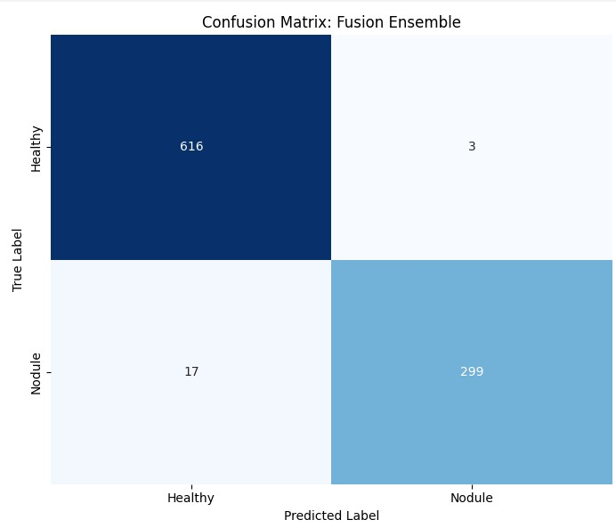Fig 4. Confusion Matrix of TSFE Model

Acknowledgment
The authors would like to express their sincere gratitude to the project supervisor and faculty members of the Department for their valuable guidance, encouragement, and continuous support throughout the course of this work. The authors also acknowledge the institution for providing the necessary computational resources and facilities required for carrying out the experiments. Special thanks are extended to peers and reviewers whose constructive feedback contributed to the improvement of this work.

References
[1] S. Liu et al., "Accurate classification of lung nodules on CT images using the TransUnet," Front. Public Health, vol. 10, Art. no. 1060798, Dec. 2022.
[2] Y. Zhang et al., "A multi-task model for pulmonary nodule segmentation and classification," BMC Med. Imaging, vol. 24, p. 234, Sep. 2024.
[3] Y. Wang et al., "Dual-branch feature fusion S3D V-Net network for lung nodules segmentation," Biomed. Signal Process. Control, vol. 92, p. 106845, Jun. 2024.
[4] X. Li et al., "FusionLungNet: Multi-scale fusion convolution with refinement network for lung CT image segmentation," arXiv preprint arXiv : 2410.15812, 2024.
[5] J. Zhang et al., "Fusion networks of CNN and transformer with channel attention for lung nodule detection," Front. Public Health, vol. 11, Art. no. 1295431, Dec. 2023.
[6] H. Chen et al., "A hybrid CNN-transformer model for predicting N staging and prognosis of NSCLC," BMC Med. Imaging, vol. 24, p. 251, Oct. 2024.
[7] L. Wang et al., "Federated lung nodule segmentation using a hybrid transformer-U-Net," IEEE J. Biomed. Health Inform., early access, Jan. 2026.
[8] Q. Zhao et al., "MLND-IU: A multi-stage detection model of sub centimeter lung nodules with dynamic focal loss," IEEE Trans. Med. Imaging, vol. 45, no. 2, pp. 567–578, Feb. 2026

